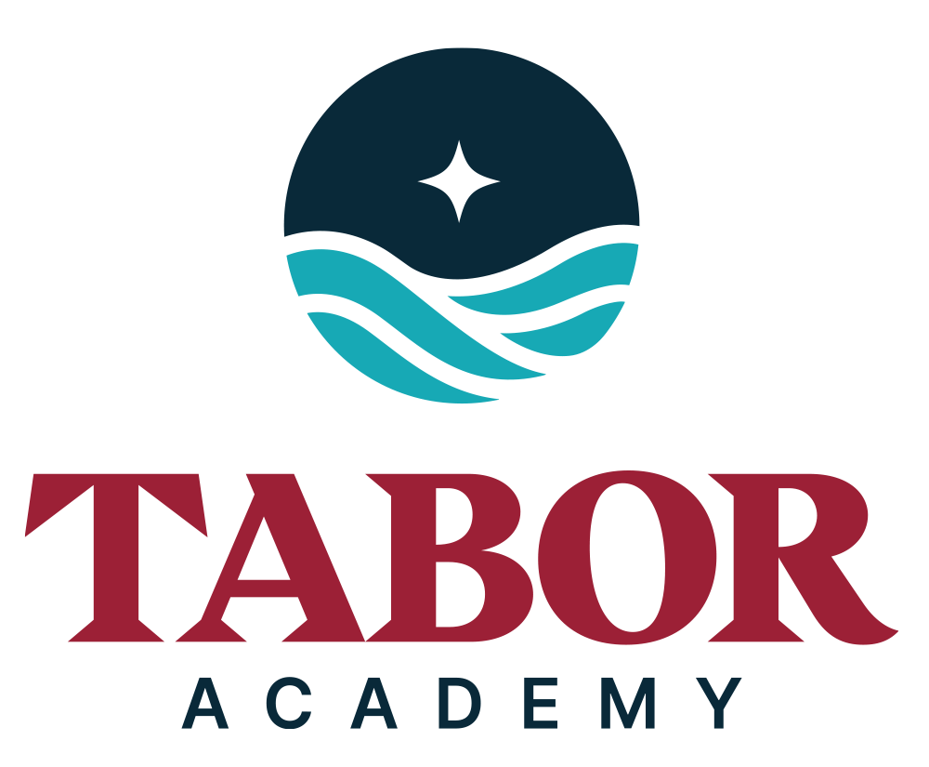
Tabor Summer Camp Activities

2026 ACTIVITY OFFERINGS
**Note - If enrollment is low for any offering, it may be cancelled.

Art Exploration
Calling all young budding artists. This activity is designed to encourage your artistic expression, art appreciation, understanding, and imagination. You will have the chance to try out fun new art processes and exhibit your work.

Archery (5th to 10th grade) – Not available for day campers! Moved to Weekend and Residential Programing!
Archery is a terrific solo sport. Campers are taught how to set up a proper line of archers, how to put on an arm guard, and load and shoot arrows. Staff will oversee stance and arrow release.

Baseball
Learn the art of throwing, hitting, fielding, base running, and pitching! Get the tools necessary for the next level of play. You will work hard, make new friends, and have fun while focusing on great sportsmanship.

Basketball
There’s plenty of time to practice your shot! You will learn proper ball handling techniques, how to shoot, how to play both offense and defense, and how to be a member of a team.

Ceramics *
This is a hands-on experience for you to learn the craft of clay, while having fun and exploring your creativity. A wide variety of ceramic techniques are taught from throwing simple pieces on the potter’s wheel, shaping clay into pinch pots, decoration, glazing, and firing. Note, the last week campers may use an air-drying process.
*2-week consecutive enrollment commitment required.

Crack the Cube
Ever wonder how some people can solve the Rubik’s Cube™ with such ease? Is there a formula to the solution or do some people just have what it takes to get each side to be its own color? You will find answers to these questions and learn to solve the Rubik’s cube!

Craft Creations
It is here that you will explore activities that you can have fun with. Learn how to make cool crafts, create critters, sew, glue, paint, pyrography, make jewelry, and much more! Ready? Great! Let's Go!
Drama
Develop your talents in the arts in this fun, non-competitive atmosphere. It’s all about expressing yourself! Show off your talent in mini productions presented at the end of each week where you will have a chance to shine on stage.
Flag Football (4th to 10th grade)
Engage in a fun, non-contact flag-style football experience with focus on formations, skill development, and field play execution. Ready, set, hike!

Kayaking
Kayaking will help build paddling skills, confidence, and an appreciation for our beautiful harbor. Each day we will enhance our kayaking skills, focusing on “water safety” and using fun and interactive games to develop skills.

Nature Quest
Do you love the outdoors? Do you want to connect with nature? Campers will have a chance to explore and gain confidence in the natural world. Activities will include, hiking local trails, visiting our shores, creating nature art, growing micro-greens, and more.

Soccer
The game of soccer, more commonly referred to outside the United States as football, has long been one of the most popular sports in the world. You will have the opportunity to develop your technical skills and increase your tactical knowledge while having a blast!

Swimming
The ocean is one of life’s great joys. Campers will enjoy the cool water off our swim dock and float, located directly on Sippican Harbor. Foundational water safety skills and swim stroke techniques will be taught, under the watchful eyes of trained lifeguards. This is a great activity that campers who LOVE the water will enjoy! (NOTE: PFDs may be required depending on campers’ skill level)

Tennis
Whether you are just starting out or a more advanced player, we offer 3 levels of instruction geared towards improving your tennis game. Players receive first class instruction, including strokes, drills, and match play.

Ultimate Frisbee
Learn the flick, backhand, and hammer in ultimate frisbee, an exciting, non-contact team sport, played by thousands the world over. Come join the fun on one of our grass fields!

Signing Up

- There are 3 activity periods in a half day program and 5 activity periods in a full day program. Please refer to our daily schedule at http://taborsummer.org/daily-schedule.
- Your child must be enrolled in the program to sign up for activities.

- Go to your Camp in Touch Account and click on Forms & Documents.

- Find the Activities Preferences form and fill out your selections.
The top choice is considered your #1 and the bottom choice is considered the activity you prefer least.

- Select 5 options for a half-day camper and 8 options for a full day camper and select the ‘ADD PREFERENCES’.

- If your child is enrolled in the Explorer Track of the Ocean & Climate Institute and the Cruising Class of the Tabor Sailing School, please select 5 activities.

- Please discuss with your camper about their interests before selecting options.

PLEASE NOTE:
- All offerings are non-competitive and start at beginner level instruction.
unless specific levels are noted.
- If selecting any ocean related offering, please make sure your child is comfortable in/around the water. Please bring swimsuit and towel on their first day.
- Ceramics offering requires a 2-week consecutive weekly enrollment period.
- Scheduling is not done until the week before the summer program begins, when the staff arrives, and campers receive their schedules on their first day.
- For any offerings that have grade specifications, the camper must be entering into the required grade the following fall.
- We cannot always accommodate requests for family/friends to be placed in the same activities.
- We strongly encourage campers to stay in their scheduled activities for the duration of their program as we feel it helps them build connections with their counselors, other campers and helps them further develop their skills in their chosen activity/course.
- If campers wish to change an activity after they start their program, please refer to our SCHEDULE AND CHANGE REQUEST policy located in the Parent Handbook and on our 'Start of Camp' page at https://taborsummer.org/start-of-camp.
- Activity offerings are subject to change based on our ability to hire qualified staff.
- If enrollment is low for any offering, it may be cancelled.
- TABOR SUMMER CAMP supplies all equipment needed for activities. If your child brings their own equipment, it must be labeled. We ask that parents do NOT bring equipment for Archery. Children are responsible for their property as TABOR SUMMER CAMP is not liable for any loss, theft, or damage to your camper’s belongings.

